1.)
Print: https://www.timvandevall.com/wp-content/uploads/Jigsaw-Puzzle-Piece-Template.pdf
Activity: Color and design the puzzle piece however you’d like. Happy Autism Awareness Month!

2.)
Activity: Work on word families with your child! Pull the plastic eggs apart so you have two halves. On one half, write a 2-letter word ending of your choice. On the other half, write 4 or 5 different letters around the edge of the egg, making sure to use letters that will make a word when joined with the 2-letter word ending on the other half. Snap the halves back together and twist the egg around until you line up each letter with the word ending. Have your child say each word they make!
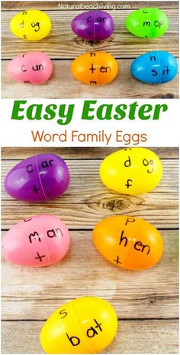

3.)
Activity: Use sight words, write the alphabet, or write your child’s name. Use a white crayon and write on a piece of paper. Next, use watercolor or chalk to shade over the writing. Finally, the letters/words will appear!
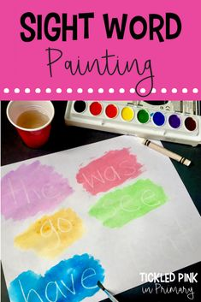

4.)
Activity: Focus on shapes, coloring, and body part recognition! Draw the shapes: square, triangle, diamond, and rectangle. Your child will decorate the shape to make it a Monster.
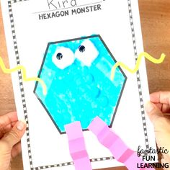

5.)
Activity: Count 10 yellow objects and 10 black objects around the house.
Example— Parent: I see a yellow banana, what can you find that is yellow?
Child: I found a yellow marker.
6.)
Watch: https://www.weareteachers.com/best-virtual-field-trips/
Activity: Pick a new field trip to watch.

7.)
Watch: https://www.youtube.com/watch?v=Zh4V0vfN5QE
Activity: Discuss what you saw and what you loved about the latest version of Soarin’ At Epcot.

8.)
Activity: Make a number line!

Materials:
- Post-it Notes
- Tape
- Butcher paper (or tape up individual sheets of paper)
- Marker

Directions:
1. Start by rolling out the butcher paper along my wall and adding a giant line down the middle.
2. Measure the Post-it notes to make sure each line can fit 20 numbers on it.
3. Take the Post-its and write numbers 1–20 on them. Mix them up.
4. Have your child build their number line by putting the mixed up Post-it notes back in numerical order.

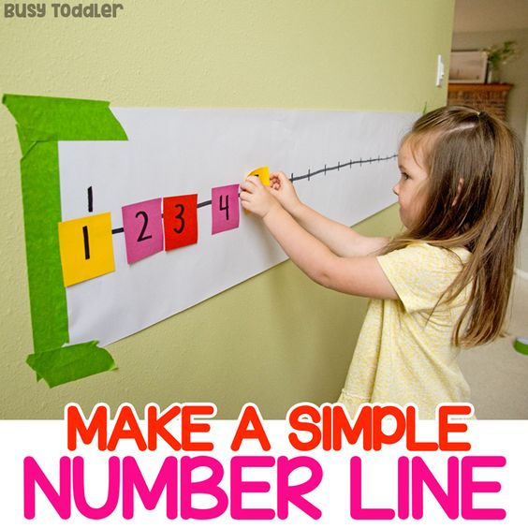

9.)
Activity: Cut pictures/words out of a magazine that would make you a Good Citizen. Glue them to a poster board and draw yourself!
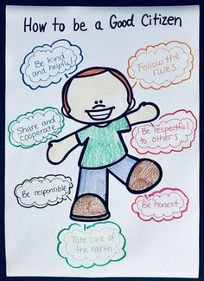

10.)
Watch: https://www.youtube.com/watch?v=JxdrEFz9Jsw
Watch: https://www.youtube.com/watch?v=koK9ihdqFwk
Activity: Using construction paper or computer paper, cut out squares (your child can cut out the traced squares). Cut out a circle for the head then build your doctor. Have fun!
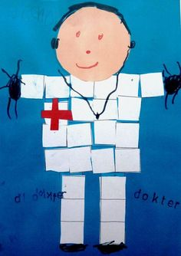

11.)
Activity: Write numbers and have your child use stickers to count out each number. If you don’t have stickers, draw circles or any shape you’d like!
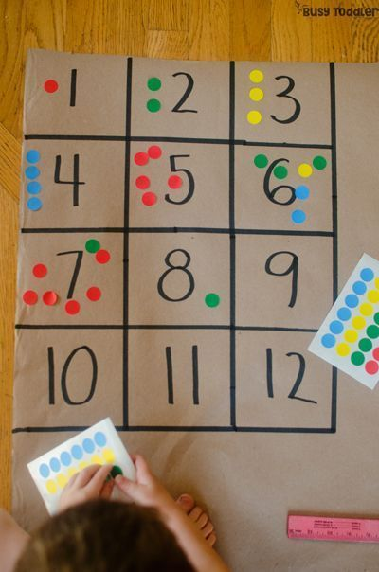

12.)
Activity: Write out numbers on paper and hide numbers in a box of sand. Match the hidden numbers to the written numbers!
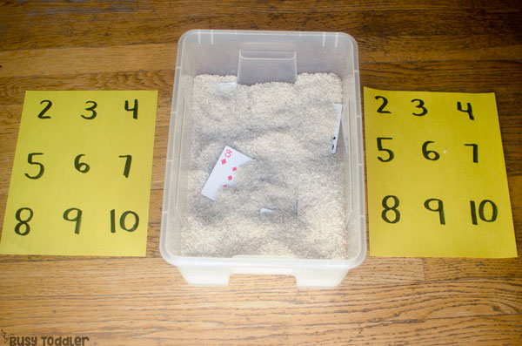
* For the hidden numbers, you can use puzzle pieces, flash cards, or a card deck of cards.
*If you do not have sand to hide your numbers, use materials you have such as paper.

13.)
Activity: Write a word, letters of the alphabet, or your child’s name. Dip a cotton swab in paint and dot the word/letter.
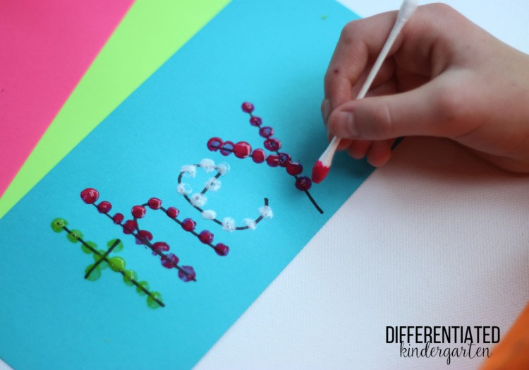
*If you do not have paint to trace over the words you can use stickers, markers, etc.

14.)
Activity: Make cake mix play dough!

Materials:
- 1 box white cake mix
- ½ cup of avocado oil or melted coconut oil
- 3 tablespoons cornstarch
- 5 tablespoons powdered sugar
- Sprinkles (optional)

Directions: Mix all ingredients together and have fun playing with your homemade play dough!
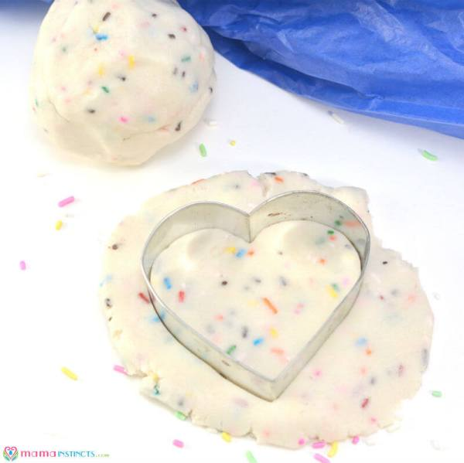
*This is edible but not the healthiest to consume!

15.)
Activity: Write out the answers on a piece of paper and write out the equation on Post-its. Your child will take the two additives that equal the number and place the Post-it on top.
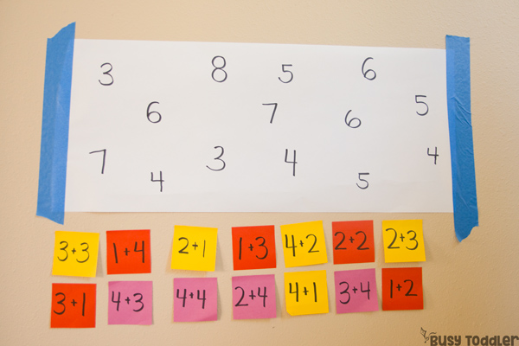

16.)
Activity: Give a random act of kindness in rock art form. Just paint, write a positive message, and decorate. Kindness rocks!
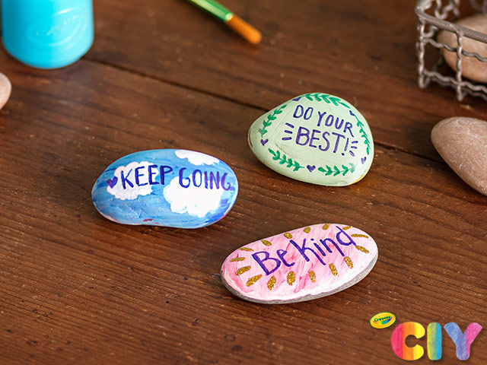

17.)
https://circletimefun.com
Activity: Choose an interactive story to read. Discuss *the sequence of events *characters *setting *plot

18.)
Watch: https://www.youtube.com/watch?v=CjRk58o-Igc
Activity: You deserve a break. A shake break!

19.)
Activity: Using tin foil, cut out an egg shape. Have your child decorate it using Sharpie markers!
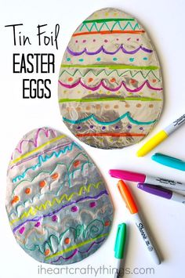

20.)
Activity: Say thank you to a nurse, police officer, or firefighter! Write a thank you card, decorate it and sign your name. Ask a family member to mail it to that special person.

21.)
Watch: https://www.youtube.com/watch?v=8ZjpI6fgYSY
Activity: Draw a picture of your favorite season. Write a few sentences about why you love this season!

22.)
https://pbskids.org/scribblesandink/draw
Activity: Use this website to create your own illustrations!

23.)
Activity: Have an alphabet scavenger hunt! Write the letters of the alphabet on index cards (or use flash cards) then hide or tape the letters around your house. Your child will search for them and tell you the letter.
*To make this more challenging, write words instead of letters. Once a word is found, have your child read the word.

24.)
Activity: Conduct an oil and water experiment!

Materials:
- Cooking oil
- 2 cups water, divided
- Food coloring
- Straws or eye droppers

Directions:
1. Fill up a small jar with cooking oil.
2. Place 1/4 cup of water in 4 separate containers.
3. Dye each water filled container a different color with just a drop or two of food coloring and mix.
4. Set your straw (or eye dropper) into one container of colored water, place your fingertip over the top of the straw, and drop the colored water into the oil by lifting your fingertip off the straw.
5. Watch how the oil and colored water droplets separate.

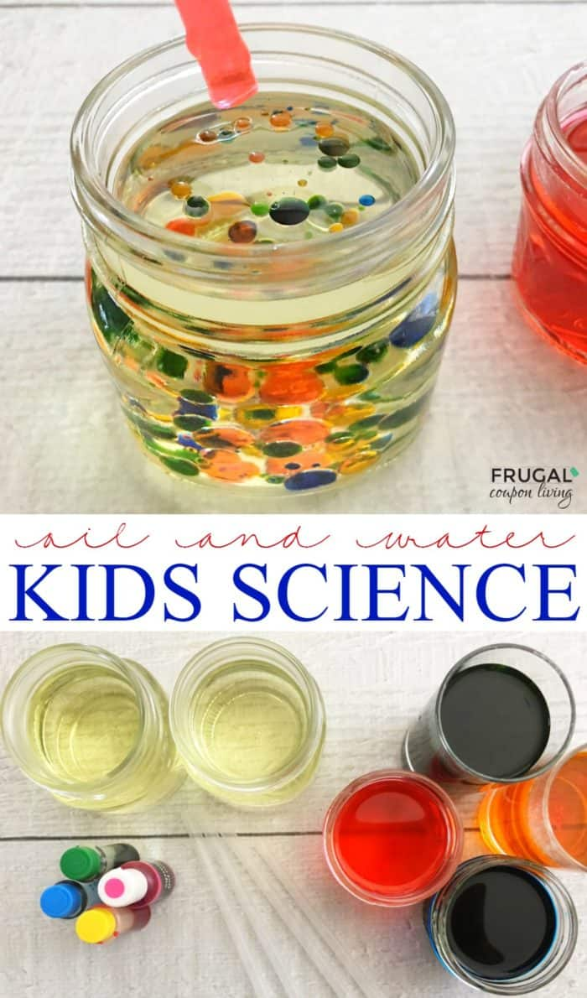

25.)
Activity: Choose words you would like to work with. Write these words on paper or index cards with a missing letter (Example: f __ s h). Use bottle caps or make circles out of construction paper with vowels a, e, i, o, u along with a few consonants. Your child will fill in the missing letter to complete the word!
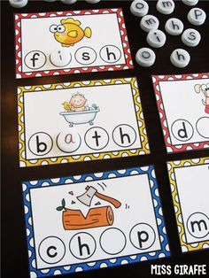

26.)
Activity: Encourage your child to count and help them to visually see the order of numbers!

Directions:
1. Cut out an egg shape from construction paper. Cut each egg in half and mark the top half with “dots” 1-10.
2. Tally mark the bottom halves 1-10 to match the tops. Mixing up the colors of the eggs makes it a bit more challenging!
Kids need to match up the correct quantity of dots to the tally marks to complete an egg. Once all of them are matched up, let your child place the eggs in numerical order!
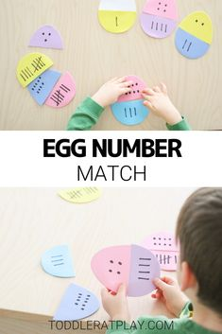

27.)
Activity: Conduct a magic milk science experiment!

Materials:
- Milk
- Liquid food coloring
- Dish soap
- Cotton swabs

Directions:
1. Pour a thin layer of milk in a shallow pan.
2. Have your child add drops of food coloring all around in the milk.
3. Direct your child to pick up a cotton swab and dip it in the dish soap.
4. Put the cotton swab in the milk – pressing it down in one spot and holding it there for about 15 seconds.
5. Watch what happens!

Questions to ask you child:
- What did you notice?
- What happened when you put the cotton swab in the milk?
- Why do you think that happened?
- Why do you think it stopped moving around after a period of time?
- What else did you observe?
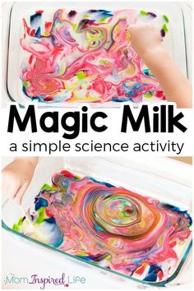

28.)
Activity: Use painters’ tape to create a large tens frame on your floor. Use it to practice adding and subtracting!

Ten frames are used for counting. They make counting values simpler. We can use them for composing and decomposing numbers in relation to 5 and 10. They help form the basis for understanding place value in the future (example: numbers like 12 are a ten and two ones)
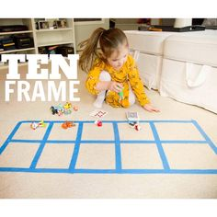

29.)
Activity: Make fluffy slime!

Ingredients:
- ½ cup Elmer’s glue
- 1 ½ cups shaving cream
- 2 ½ tablespoon of saline contact solution

Directions:
1. Add all ingredients into a medium size bowl
2. Use your hands and knead the ingredients together (the more you knead it, the less sticky it gets)
3. Add a few drops of food coloring or use markers to color your slime!
If it’s still too sticky, add more contact solution
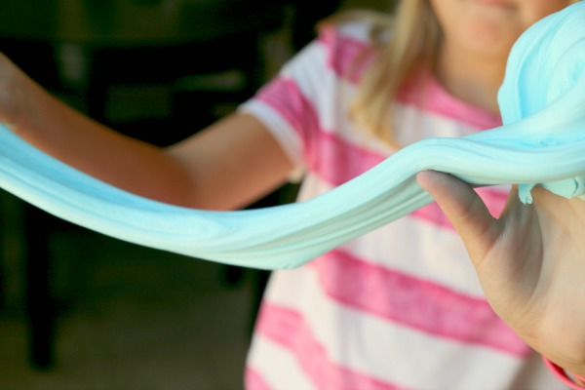

30.)
Activity: Conduct a weather experiment!

Directions:
1. Fill the cup with water (air)
2. Add a thin layer of shaving cream (clouds – water vapor)
3. Place drops of blue food coloring on the top of the shaving cream (water droplets)
4. Wait for the “rain” to fall

For this experiment it is important to remind learners that this activity shows how the water gets heavier on the top of the cloud and gravity makes it fall as rain. Let them know that we use the shaving cream and food coloring to represent the different forms of water we can easily see.

